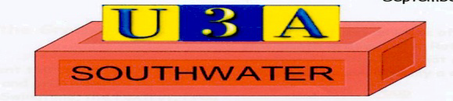

TERMS AND CONDITIONS OF MEMBERSHIP
All members must:
- Abide by the Principles of the u3a movement.
- Always act in the best interests of the u3a and never do anything to bring the u3a into disrepute.
- Abide by the terms and conditions of the constitution.
- Treat fellow members with respect and courtesy at all times.
- Comply with and support the decisions of the elected committee.
- Advise the committee of any change in your personal details.
- Abide by the Member Code of Conduct

Southwater u3a Members Code of Conduct
- Members are expected to know, follow and promote the Principles of the u3a Movement at every opportunity.
- Members must always act in the best interests of Southwater u3a and the u3a Movement, strive to uphold its reputation and never do anything which could bring their own, another u3a or the u3a Movement into disrepute or expose it to undue risk.
- Members are expected to use Southwater u3a’s resources responsibly and only to further its stated charitable objectives/purposes.
- Members are expected to reflect the current organisational policy of Southwater u3a, regardless of whether it conflicts with their personal views.
- Members are expected to abide by Southwater u3a’s procedures and practices.
- Members are expected to treat each other with dignity and respect at all times.

