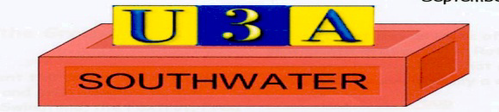

Southwater u3a Legitimate Interest Assessment – Emergency Contact

Category: Data Protection

1 Introduction
This legitimate interest assessment has been compiled in order to set out the reasons why Southwater U3A processes emergency contact information.

2 Policy
This legitimate interest assessment has been compiled in order to set out the reasons why Southwater u3a requests emergency contact details.

3 Purpose Test
The reason that Southwater u3a requests contact details for a member’s emergency contact is so that the committee and/or group convenors know who to contact in the event of an emergency. Southwater u3a has a duty of care to its membership. In order to ensure your safety we need to be able to contact someone who can meet your welfare needs in the event of an incident/accident. Southwater u3a requests members to inform the person identified as your emergency contact that you have provided their details to the u3a. For certain events and trips we may need to provide these details to a third party. You will be made aware of who this emergency contact information will be shared with if it is to be shared outside of the u3a.

4 Necessity Test
The emergency contact information provided by members would only be used in the event of a serious incident/accident. Southwater u3a would use the information to contact someone who may need to collect the relevant member, support the relevant member or liaise, on behalf of the relevant member, with a third party provider such as a medical professional. Southwater u3a only requests minimal information regarding members' emergency contact which includes a name, telephone number and the details of their relationship to the member.

5 Balancing Test
The emergency contact data requested is minimal and is only that which is required to make contact with the individual in question. Southwater u3a relies on its members to provide emergency contact information and to make the individual aware that this information has been passed to the u3a and for what purposes it has been passed to the u3a. Southwater u3a will hold this information securely and it will only be accessed by those who need to see it. The information provided will only be used to contact the member’s emergency contact where an incident or accident occurs that requires someone to take responsibility for the member in question. The data will not be processed for any other purposes.
Through compilation of this assessment Southwater u3a considers that it has a legitimate interest to collect, hold and process emergency contact information. This document will be held by the Committee and communicated to the membership, as required. The assessment will be reviewed every 2 years in order to ensure that legitimate interest remains the most appropriate lawful basis for gathering this information.

Drafted and adopted: 07/03/24
Review date: March 2026

Southwater u3a I Registered Charity 1178399 Website southwateru3asite.uk

